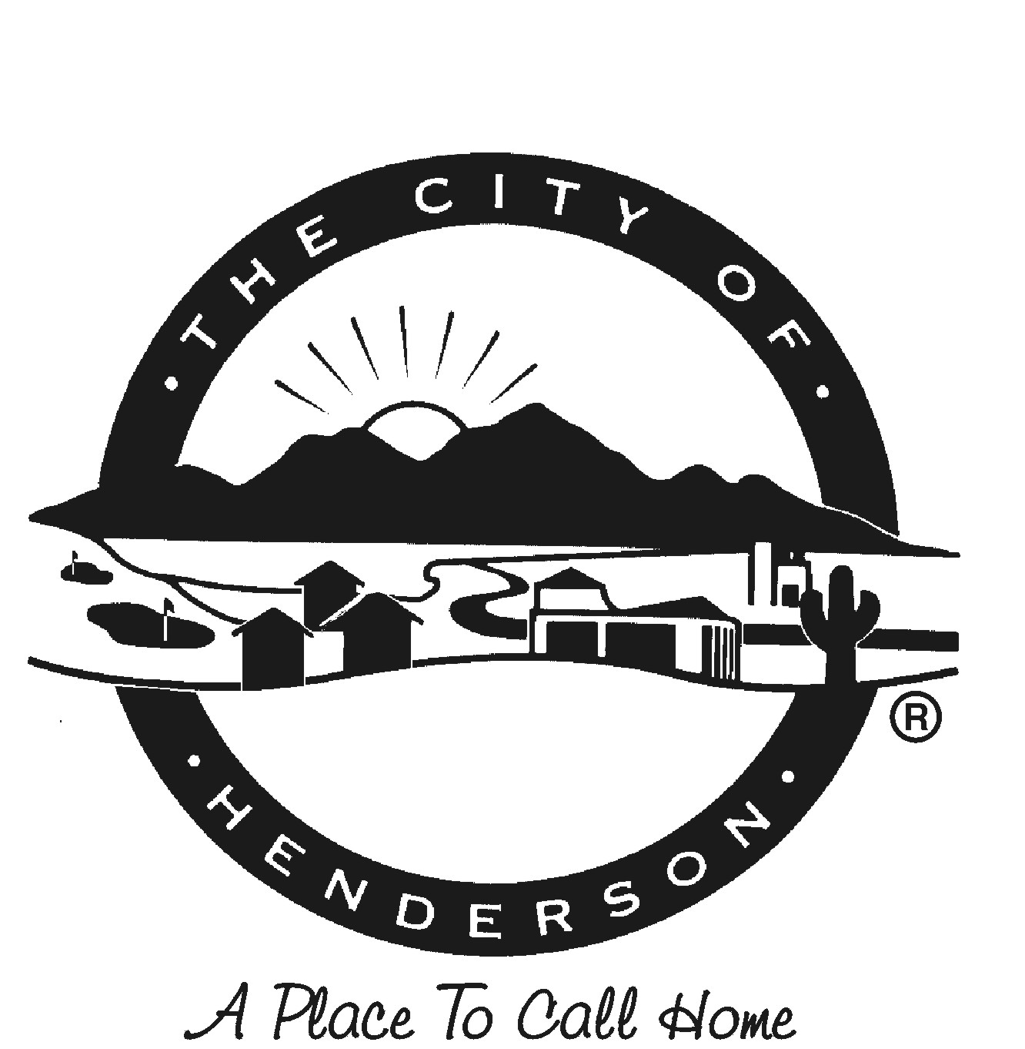
CITY OF HENDERSON
EXPRESS ASSUMPTION OF RISK, WAIVER AND RELEASE OF LIABILITY

SPECIAL EVENT VOLUNTEER

Event: ___________________________________ Event Date: _____________
Location: _________________________________

PLEASE READ THIS FORM CAREFULLY AND BE AWARE THAT BY SIGNING IT YOU WILL BE WAIVING AND RELEASING CLAIMS FOR POTENTIAL INJURIES AND PROPERTY DAMAGE ARISING FROM PARTICIPATION IN THIS EVENT.

“Participant” means the undersigned, being at least 18 years old, or the minor child (under 18 years old) and the undersigned parent or legal guardian of the minor on behalf of himself/herself (hereinafter individually and collectively the “Participant”) that will be participating in the above named City of Henderson Special Event (hereinafter referred to as the “Event”).

I, ________________________, (Participant’s name or parent’s name if Participant is under 18) being the Participant or the parent, natural and or legal guardian of the child listed at the bottom of this waiver give permission for and agree that I, or my minor child, will participate as a volunteer at the above named Event. By doing so, I acknowledge, understand, and agree to the conditions below (Participant or Parent, if Participant is under 18 years old must initial each item):
- I acknowledge that I understand the physical nature of the activity and that the Participant is in good health, and in proper physical condition to participate in such activity. I fully understand that participation at the Event may involve the inherent risk of bodily injury, including, but not limited to, broken bones, torn ligaments, dislocated joints, head injury, cardiac arrest, stroke, muscle strain and sprain, back injury, joint pain, abrasions, bruising and shortness of breath which may result in permanent disability, paralysis and/or loss of life. There are also outdoor risks of sun exposure, inclement weather, and poor air quality. Due to the nature of this Event, I understand that these and other risks may be caused by the Participants own actions or inaction; or by others participating in this Event.
Participant’s / Parent’s Initials _________

- To the fullest extent allowed by law, I hereby voluntarily release, forever discharge, and agree to indemnify and hold harmless the City of Henderson, its employees, officers, agents, volunteers, and administrators (the “Released Parties”) from any and all claims, demands, or causes of action, which are in any way connected with me or my minor child’s participation in this Event or my/my child’s use of City of Henderson equipment or facilities, including any such claims which allege negligent acts or omissions of City of Henderson.
Participant’s / Parent’s Initials _________

- I expressly agree and promise to accept and assume all of the risks existing in this Event. My or my child’s participation in this Event is purely voluntary, and I elect to participate or to allow my child to participate in spite of the risks.
Participant’s / Parent’s Initials _________

- MEDIA RELEASE - I hereby grant to the City of Henderson and those acting with its permission or upon its authority the absolute and unqualified right and permission to copyright (in its own name or otherwise), produce, publish, distribute, and otherwise use any photographs, motion pictures, other audio-visual works, electronic representations and/or sound reproductions (collectively, "Original Work") that include a depiction/recording of me and/or the minor named below. I hereby assign to the City of Henderson any right, title or interest that either or both of us may have or be deemed to have therein. I hereby waive any opportunity or right that I may have to inspect or approve the finished Original Work.
I hereby waive, release and discharge the City of Henderson from any claim, demand, action or suit for defamation, invasion of privacy, or any violation of publicity, or for any other negligent or intentional conduct relating to the publication or use of the Original Work. The City will not use the Original Work in a distorted or altered manner or in any manner that might reasonably result in embarrassment, ridicule or humiliation. In the Original Work the City may identify me and the named minor only by name, title and department and may not disclose addresses or other personal identifying information.
Participant’s / Parent’s Initials _________

As the Participant or the parent or legal guardian of the Participant, I have carefully read, understand and agree to the foregoing conditions of this Express Assumption of Risk, Waiver and Release of Liability as a condition of admission and participation of the Participant. I understand that by signing this Express Assumption of Risk, Waiver and Release of Liability, I am giving up the right to make any claim against the City of Henderson, its employees, officers, agents, volunteers, and administrators on behalf of the Participant, his/her parents, natural or legal guardians, executers, administrators, heirs, and assigns. I hereby indemnify and hold the City of Henderson harmless from any and all claims brought by the Participant, his/her parents, natural or legal guardians, executors, heirs, and assigns, and/or any third party relating to my or my child’s participation in the Event. By signing this document, I acknowledge that if anyone is hurt or property is damaged during my participation in this Event, I may be found by a court of law to have waived my right to maintain a lawsuit against the City of Henderson on the basis of any claim from which I have released them herein. I have had sufficient opportunity to read this entire document. I have read and understood it, and I agree to be bound by it.

________________________________________________ _______________________
Signature of Participant or Parent/Guardian Date

Print Name of Participant or Parent/Guardian

Listed Minor Participant (under the age of 18) Information:

Print Name of Minor: _______________________ Date of Birth: _____________ Relation: ______________
MM/DD/YYYY

